# **AWS**

# 

# **S3 Backup and Restore using AWS Backup**

Step 1: login to aws management console and navigate to s3 dashboard.

Step 2 : Create a s3 bucket with “object ownership: ACLs enabled” and “bucket versioning: enabled”.

Step 3: Now,upload any object in the bucket for testing purposes .

Step 4: move to AWS backup dashboard and create a “on-demand backup” .To create a on-demand backup:

* Select resource type as “s3” and select your bucket in “bucket name”.
* Select backup window type as “ create backup now”.
* Select the retention period as per your requirements .here we choose for 1 day.
* Now create a backup vault .To create a backup vault name the vault and choose the default KMS key.
* Choose the IAM role .Here we select the “default role” .
* And then click on “create on-demand backup”.

Step 5: Now ,if you move to backup jobs,then a job will start running .After sometime its status will change to “complete”.so wait for sometime.when tha backup job is complete,it will be ready to restore or copy.

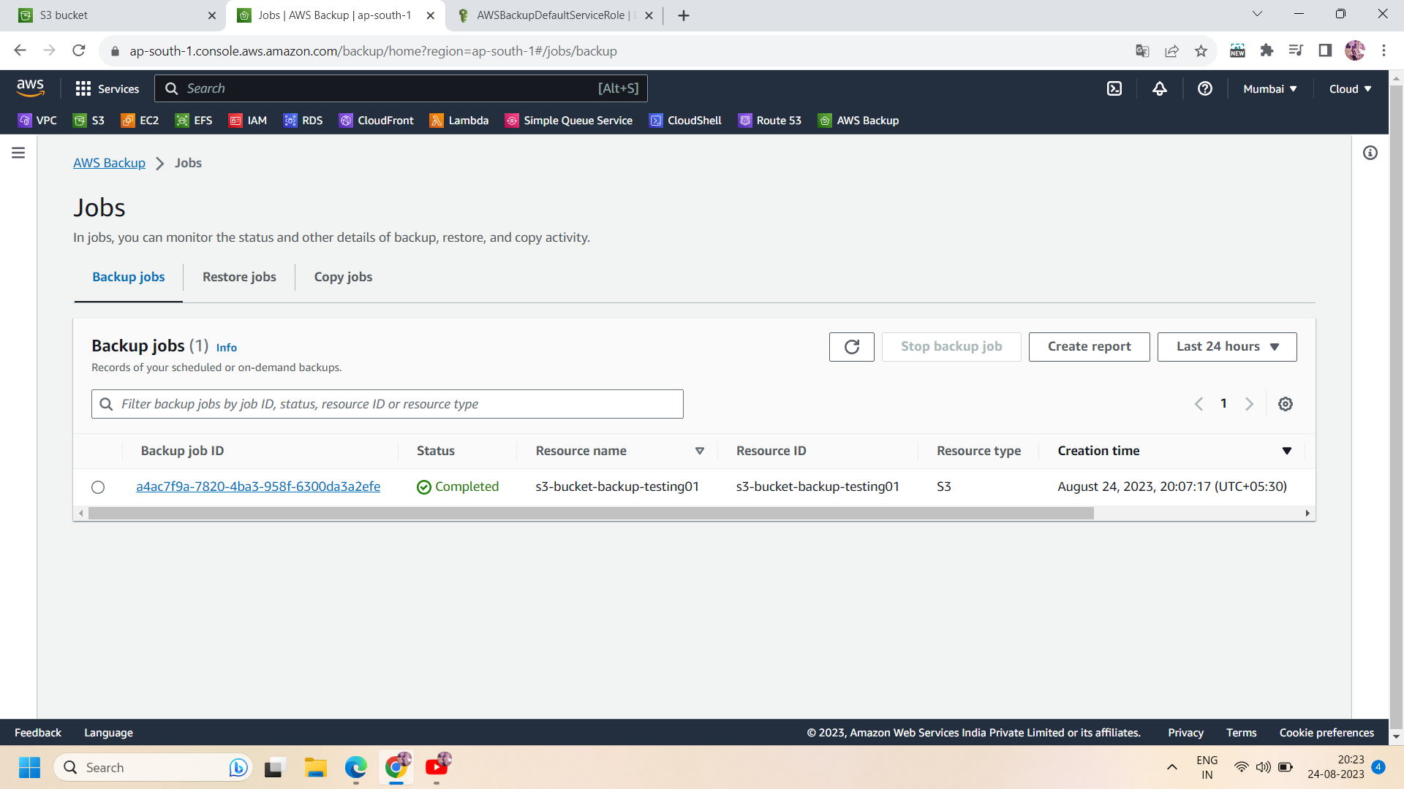

RESTORE BACKUP :-

Step 6: Now ,go to s3 bucket and delete the entire bucket.

Step 7: now ,move to aws backup dashboard and go to “backup vaults” .select your backup vault (here you will see a 1 recovery point generated after deleting the bucket).

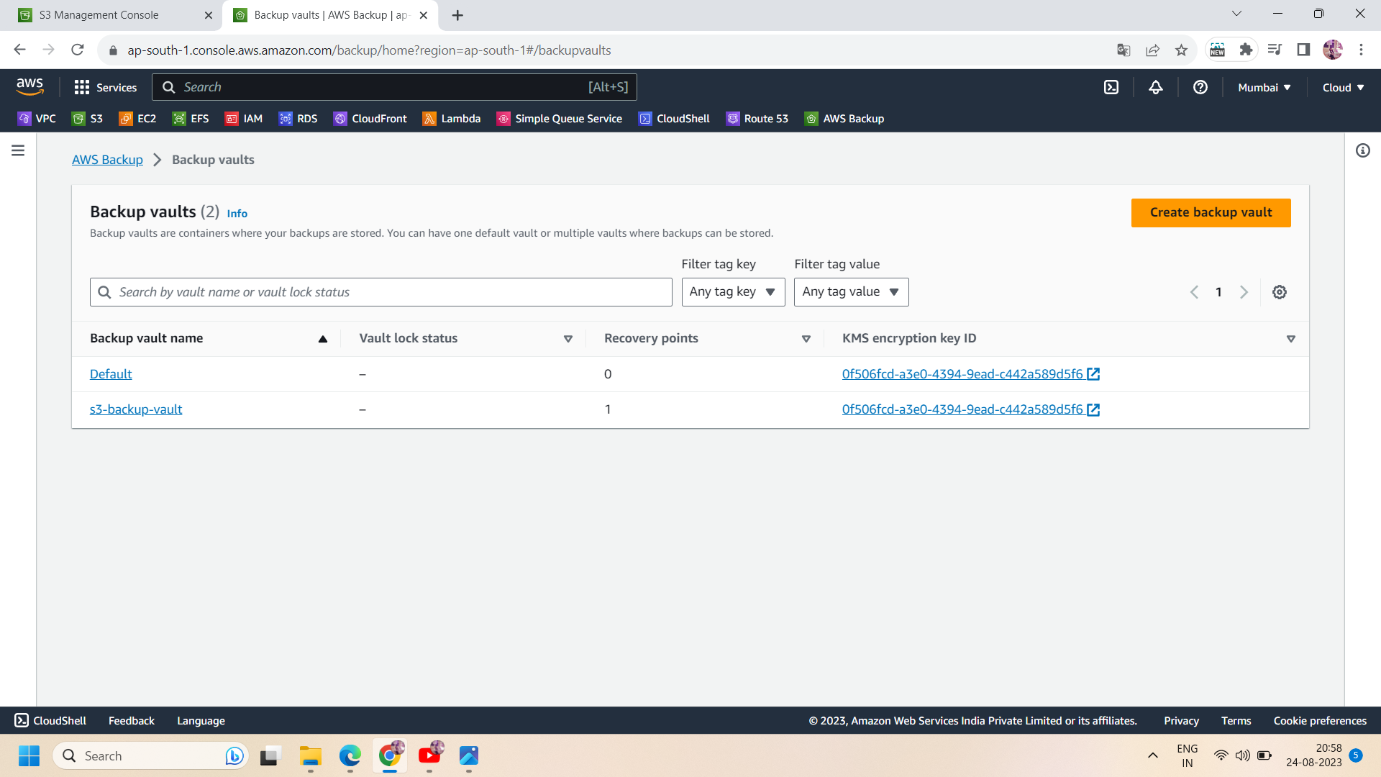

Step 8: click on your backup vault,and select your recovery backup and click on “restore” in actions.then to restore :

* You can restore an entire bucket or any specific item .It depends on your preference.here we select “ restore entire bucket”.
* You can choose any type of destination .Here we choose “restore to source bucket”.
* Select the restored object encryption as “use original encryption key(default).
* Choose the “default role” as the restore role.
* Then click on “restore backup”

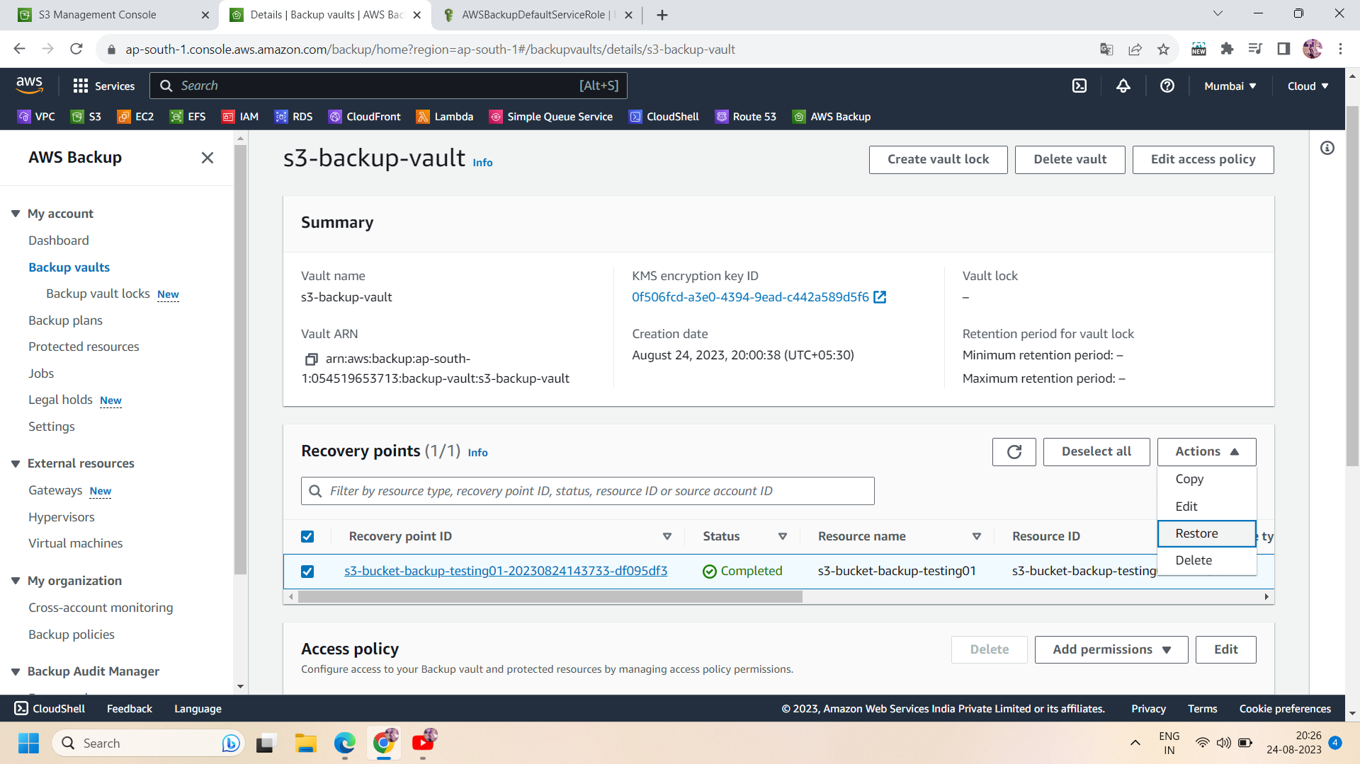

Step 8: After following the above steps,your backup restore will start running.you can check the status in “aws backup jobs” .

Step 9: go to aws backup jobs and move to its “restore jobs” .here you will find your restore job .wait until its status changes to “complete”.

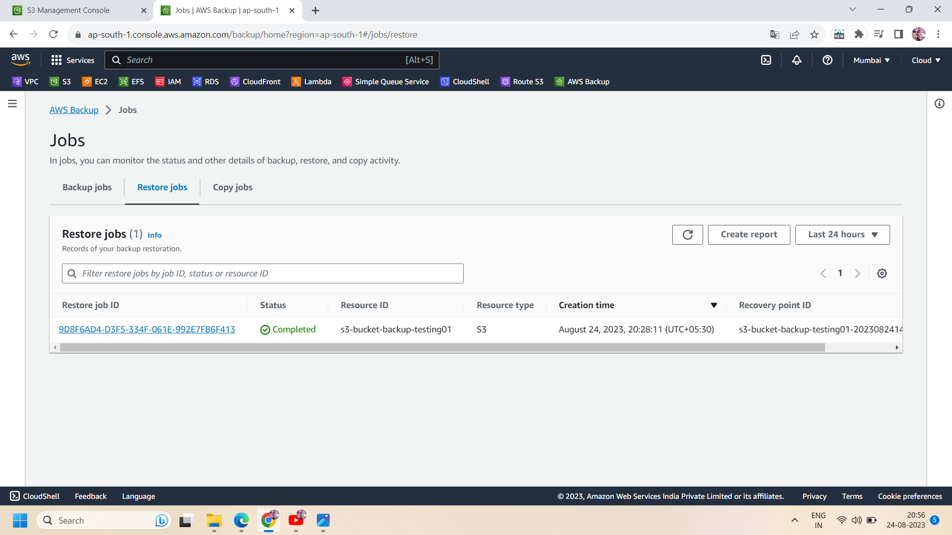

Step 10: when status changes to complete ,go to s3 bucket ,then you will see a restore bucket created by aws backup.

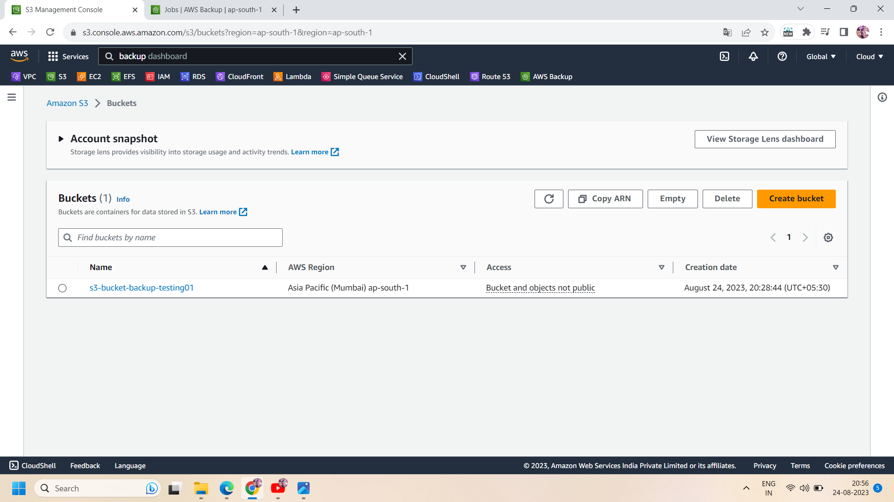

All done!!